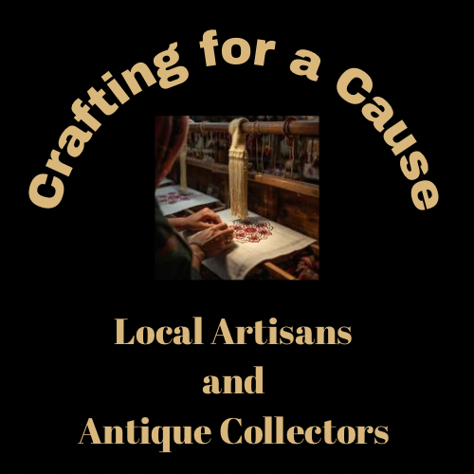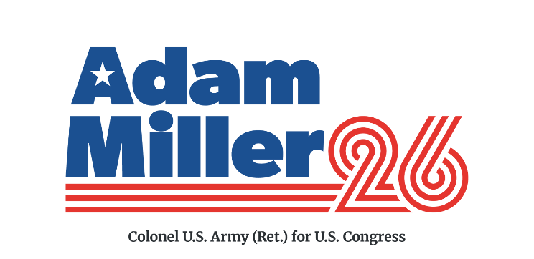

Crafting For a Cause

February 21, 2026
Fraternal Order of Eagles
1275 N Washington St Greenfield, OH 45123
11:00 A.M. to 3:00 P.M.

Vendor Application

Name _________________________________________Phone____________________
Business Name________________________________ Email____________________
Address_______________________________________City____________State______
Your Art/Craft/Collection__________________________________________________
_________________________________________________________________________
We will provide a 8 x 8-foot space.
We can provide one table. Ours? __________ You may bring your own set-up if you prefer. Yours? _________
Deadline for applying is February 7.
Send to:
Crafting for a Cause
c/o
Bootsie Robison
3139 Harriet Road
Hillsboro Ohio 45133

Set up will begin at 9:00, and should be completed by 10:45
We suggest a voluntary donation of $25 for your space.
100% of vendor participation fees will be donated to Save a Warrior.
Proceeds from your sales will stay with you.

We hope you will join us.
Hosted by Adam Miller for America, candidate for US House of Representatives Ohio District 15

